Project 1

Specimen 2

03/06/2020 13:12:38

|  |  |
| --- | --- |
| Label: | Electron Image 2 |
| Collected: | 03/06/2020 13:02:17 |
| Input Signal: | SE |
| Resolution (Width): | 512 pixels |
| Resolution (Height): | 384 pixels |
| Image Width: | 2μm |
| Image Height: | 1.5μm |
| Stage Tilt Degrees: | 0.00° |
| Specimen Tilt Degrees: | 0.00° |
| Software Tilt Correction: | Not applied |
| Magnification: | 150000 x |
| Number of Averaged Frames: | 1 |
| Dwell Time: | 35μs |

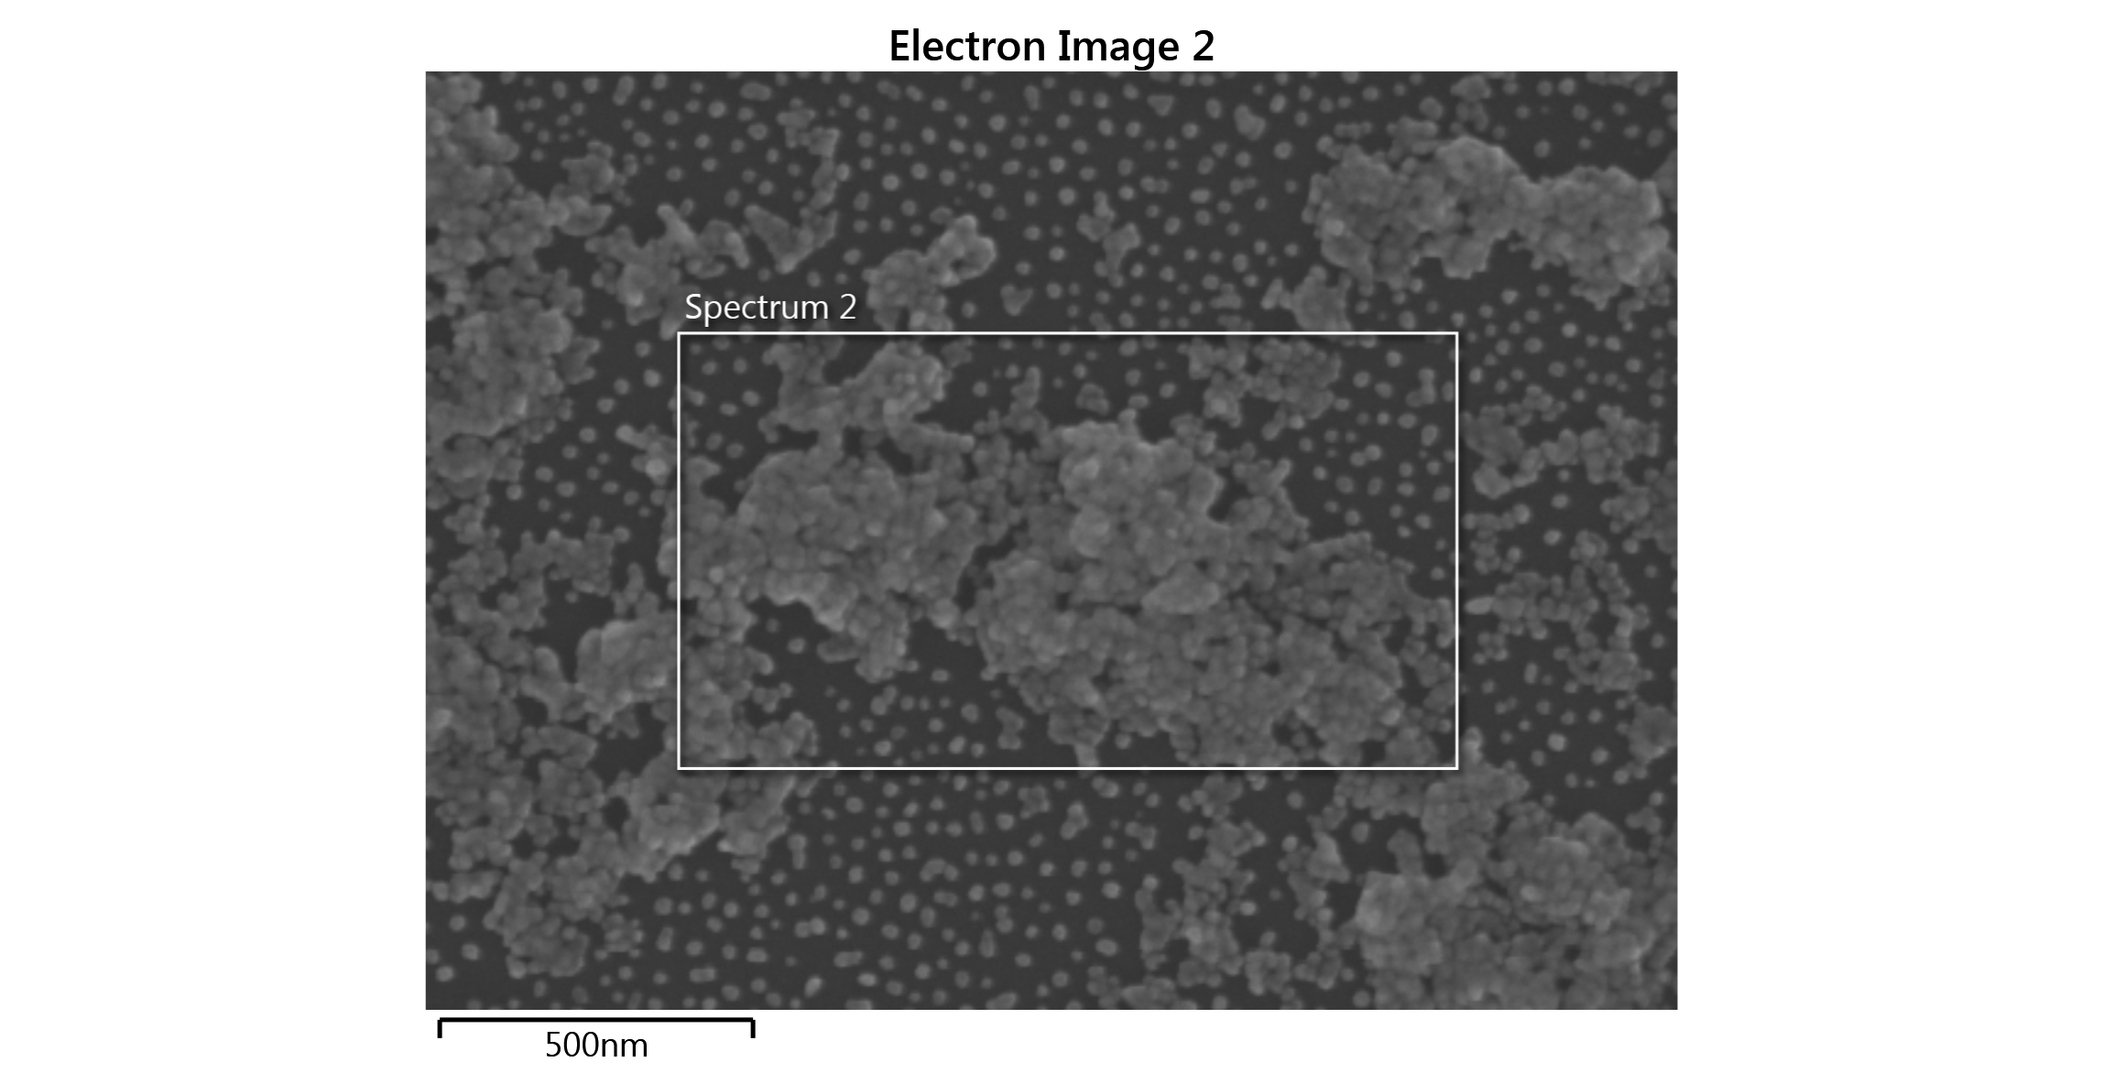

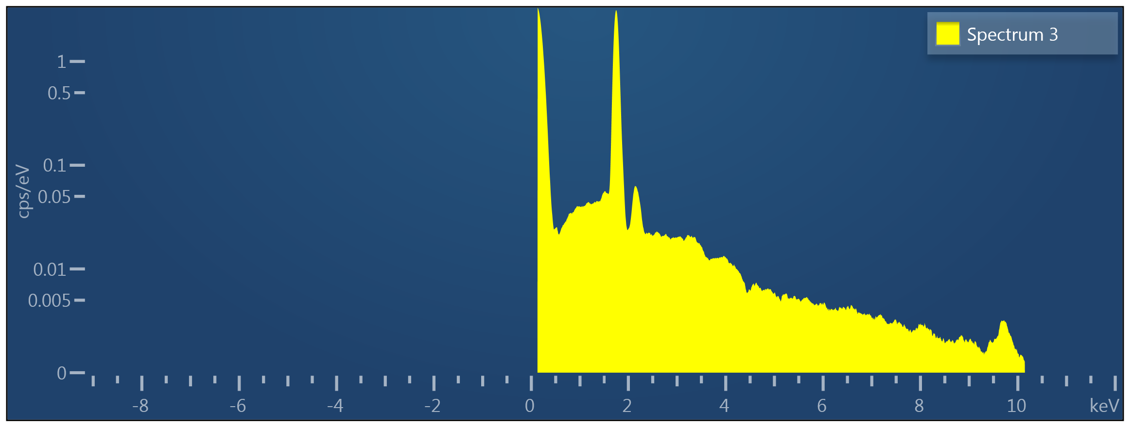

|  |  |
| --- | --- |
| Label: | Spectrum 3 |
| Source: | Acquired |
| Created: | 03/06/2020 13:12:38 |
| Livetime: | 491.0s |
| Process Time: | 5 |
| Accelerating Voltage: | 10.00kV |
| Working Distance: | 3.3mm |
| Specimen Tilt (degrees): | 0.0 |
| Elevation (degrees): | 35.0 |
| Azimuth (degrees): | 0.0 |
| Number Of Channels: | 2048 |
| Energy Range (keV): | 10 keV |
| Energy per Channel (eV): | 5.0eV |
| Detector Type Id: | 26 |
| Detector Type: | X-Act |
| Window Type: | SATW |
| Pulse Pile Up Correction: | Succeeded |

|  |  |  |  |  |  |  |  |  |
| --- | --- | --- | --- | --- | --- | --- | --- | --- |
| Element | Line Type | Apparent Concentration | k Ratio | Wt% | Wt% Sigma | Standard Label | Factory Standard | Standard Calibration Date |
| Total: |  |  |  | 0.00 |  |  |  |  |

|  |  |
| --- | --- |
| Label: | Spectrum 3 |
| Element List Type: | Current Spectrum |
| Processing Option: | All Elements |
| Coating Element: | Carbon |
| Coating Thickness: | 10 nm |
| Coating Density: | 2.25 g/cm³ |
| Automatic Line Selection: | Enabled |
| Normalization: | Enabled |
| Thresholding: | Disabled |
| Deconvolution Elements: | None |
| Selected Standards: | Quant Standardizations(Extended Set) [ Factory ] |
| Pulse Pile Up Correction: | Succeeded |
| Detector file: | x-act 6 |
| Efficiency: | File based |